Chuqi Wang

+44 7421 265183
wangchuqi@gmail.com

Education
- Imperial College London
MSc Biomedical Engineering, Neurotechnology Stream 2022 – 2023
- Modules: Neuroscience, Principles of Biomedical Imaging, Computational Neuroscience, Mathematical Methods for Neural Science and Engineering
- Individual project: ‘Tracking Changes in Brain Organoid Spontaneous Activity Over Maturation’ Focused on the temperature control during the imaging process. Collecting and analysing of calcium imaging data of early age human and mouse cerebral organoid maturity, neural activity and network-level dynamics.

- University College London
BSc Physics with Medical Physics 2019 – 2022
- Modules: Mathematical Methods, Practical Physics and Computing, Medical Electronics and Neural Engineering
- Individual project: ‘Biofeedback with EMG Sonification and Music’
Built a prototype that converts muscle signals to musical sound and test its possibilities in biofeedback. Experienced in signal processing, electronics, understanding auditory nervous system, and tackle engineering problem.
- QUEEN ANNE’S SCHOOL Reading
A-levels 2017 – 2019
Mathematics (A), Physics (A), Chemistry (A)

- READING GIRLS’ SCHOOL Reading
GCSEs 2015 - 2017
11 GCSEs, Grade A* - A in maths and sciences

Work Experience
01/08/2022-23/09/2022 UCL Biomedical Ultrasound Group, London
Research Assistant
This project revolved around the examination of a ultrasound therapy system with new launched GUI software. Conducted calibration experiments and collaborated with the supplier company to compose a user guide of the system.

Organisational skills:
- Accomplished the tasks in time and modified the experimental design along the process
Critical thinking:
- Troubleshooting from both the hardware and the software driven the ultrasonic beam

02/2018-05/2018 Volunteer, local primary school, Reading
Management:
- Prepared 45 minutes of teaching content for each week’s session with a primary student
- Developed communication skills and the ability to deliver knowledge clearly
- Got positive feedbacks from both the students and their teachers

Extra-curricular Activities & Achievements
10/2019-06/2020 UCL Chinese Student and Scholars Association
Executive
Communication:
- Took part in the self-organised performance for the Chinese Spring festival
- Promoted with marketing in the preparation work

2018-2022 The Duke of Edinburgh’s Gold Award
Adaptability:
- Took a four-day hiking expedition in the Lake District
- Stepped out of my comfort zone and learnt the importance of decision making as a team
Summer 2017 National Citizen Service, Reading
Project management:
- Organised an event in a care home with a team
- Took part in writing the project plan and fundraising

Skills and Interests
IT: Microsoft, MATLAB and Python

Technical Skills: Arduino; electronic circuits design; 3D modelling in Fusion 360; two-photon microscope
operation; tissue culture; neural spike train analysis; computational modelling of neural network.

Languages: Chinese (native), English (fluent)

Interests: Piano, dance, sports

References
References available upon request.

Motivation letter
Dear MSc IDB Admissions Committee,
I am writing to express my sincere interest in the Interdisciplinary Brain Science Master’s Program at Neuroscience Center Zurich. My motivation stems from a profound passion for neuroscience and upon reviewing the program’s materials, I am convinced that its great blend of academic and practical components aligns with my aspirations to enhance my research skills and broaden my knowledge in the intricate field of brain science.
I hold a BSc degree in Physics with Medical Physics from University College London and an MSc degree in Biomedical Engineering from Imperial College London. My academic journey has been multidisciplinary, encompassing physics, biology, engineering and computer science, with a specialization in biomedical applications. This diverse background has provided me with a comprehensive understanding of the interconnection of the basic principles, mechanisms, techniques and models across various disciplines, particularly within the realm of neuroscience.
My initial fascination with brain science developed during my undergraduate project, which focused on the application of brain-machine interfaces, with a direction of exploring the potential of auditory biofeedback through decoding the EMG signals and the reprocessing of the human auditory nervous system. This attempt sparked numerous questions in my head about the underlying mechanisms of the nervous system, such as the intricacies of information and feature selection. Recognising the constraints of my familiarity with techniques in neuroscience at the time, I am eager to advance my technical proficiency parallel with deepening my knowledge. By pursuing my academic journey in a Master’s program that specialised in Neurotechnology, I reinforced my commitment to contributing in the field of neuroscience. The hands-on experience of processing neural data and computational modelling at various levels of neural mechanisms intensified my interest in conducting research in this vibrant field. The prospect of unraveling the complexity of the human brain and translating research into meaningful clinical applications aligns with my research interests and goals.
The program’s emphasis on practical work and collaborative learning resonates with my preferences and provides an ideal platform for my academic and professional development. I believe that the interdisciplinary nature of the program, along with its focus on real-world research and collaboration with industry professionals will inspire and prepare me for meaningful and more independent research in my future journey.
Lastly, I am genuinely excited about the prospect of immersing myself in the dynamic academic and living environment of Switzerland during the IDB Master’s program. I am eager to contribute to and benefit from the rich academic community at UZH and ETH.
Thank you for considering my application. I am enthusiastic about the possibility of being shortlisted and advancing to the next stage of the application process.

Yours Sincerely,
Chuqi

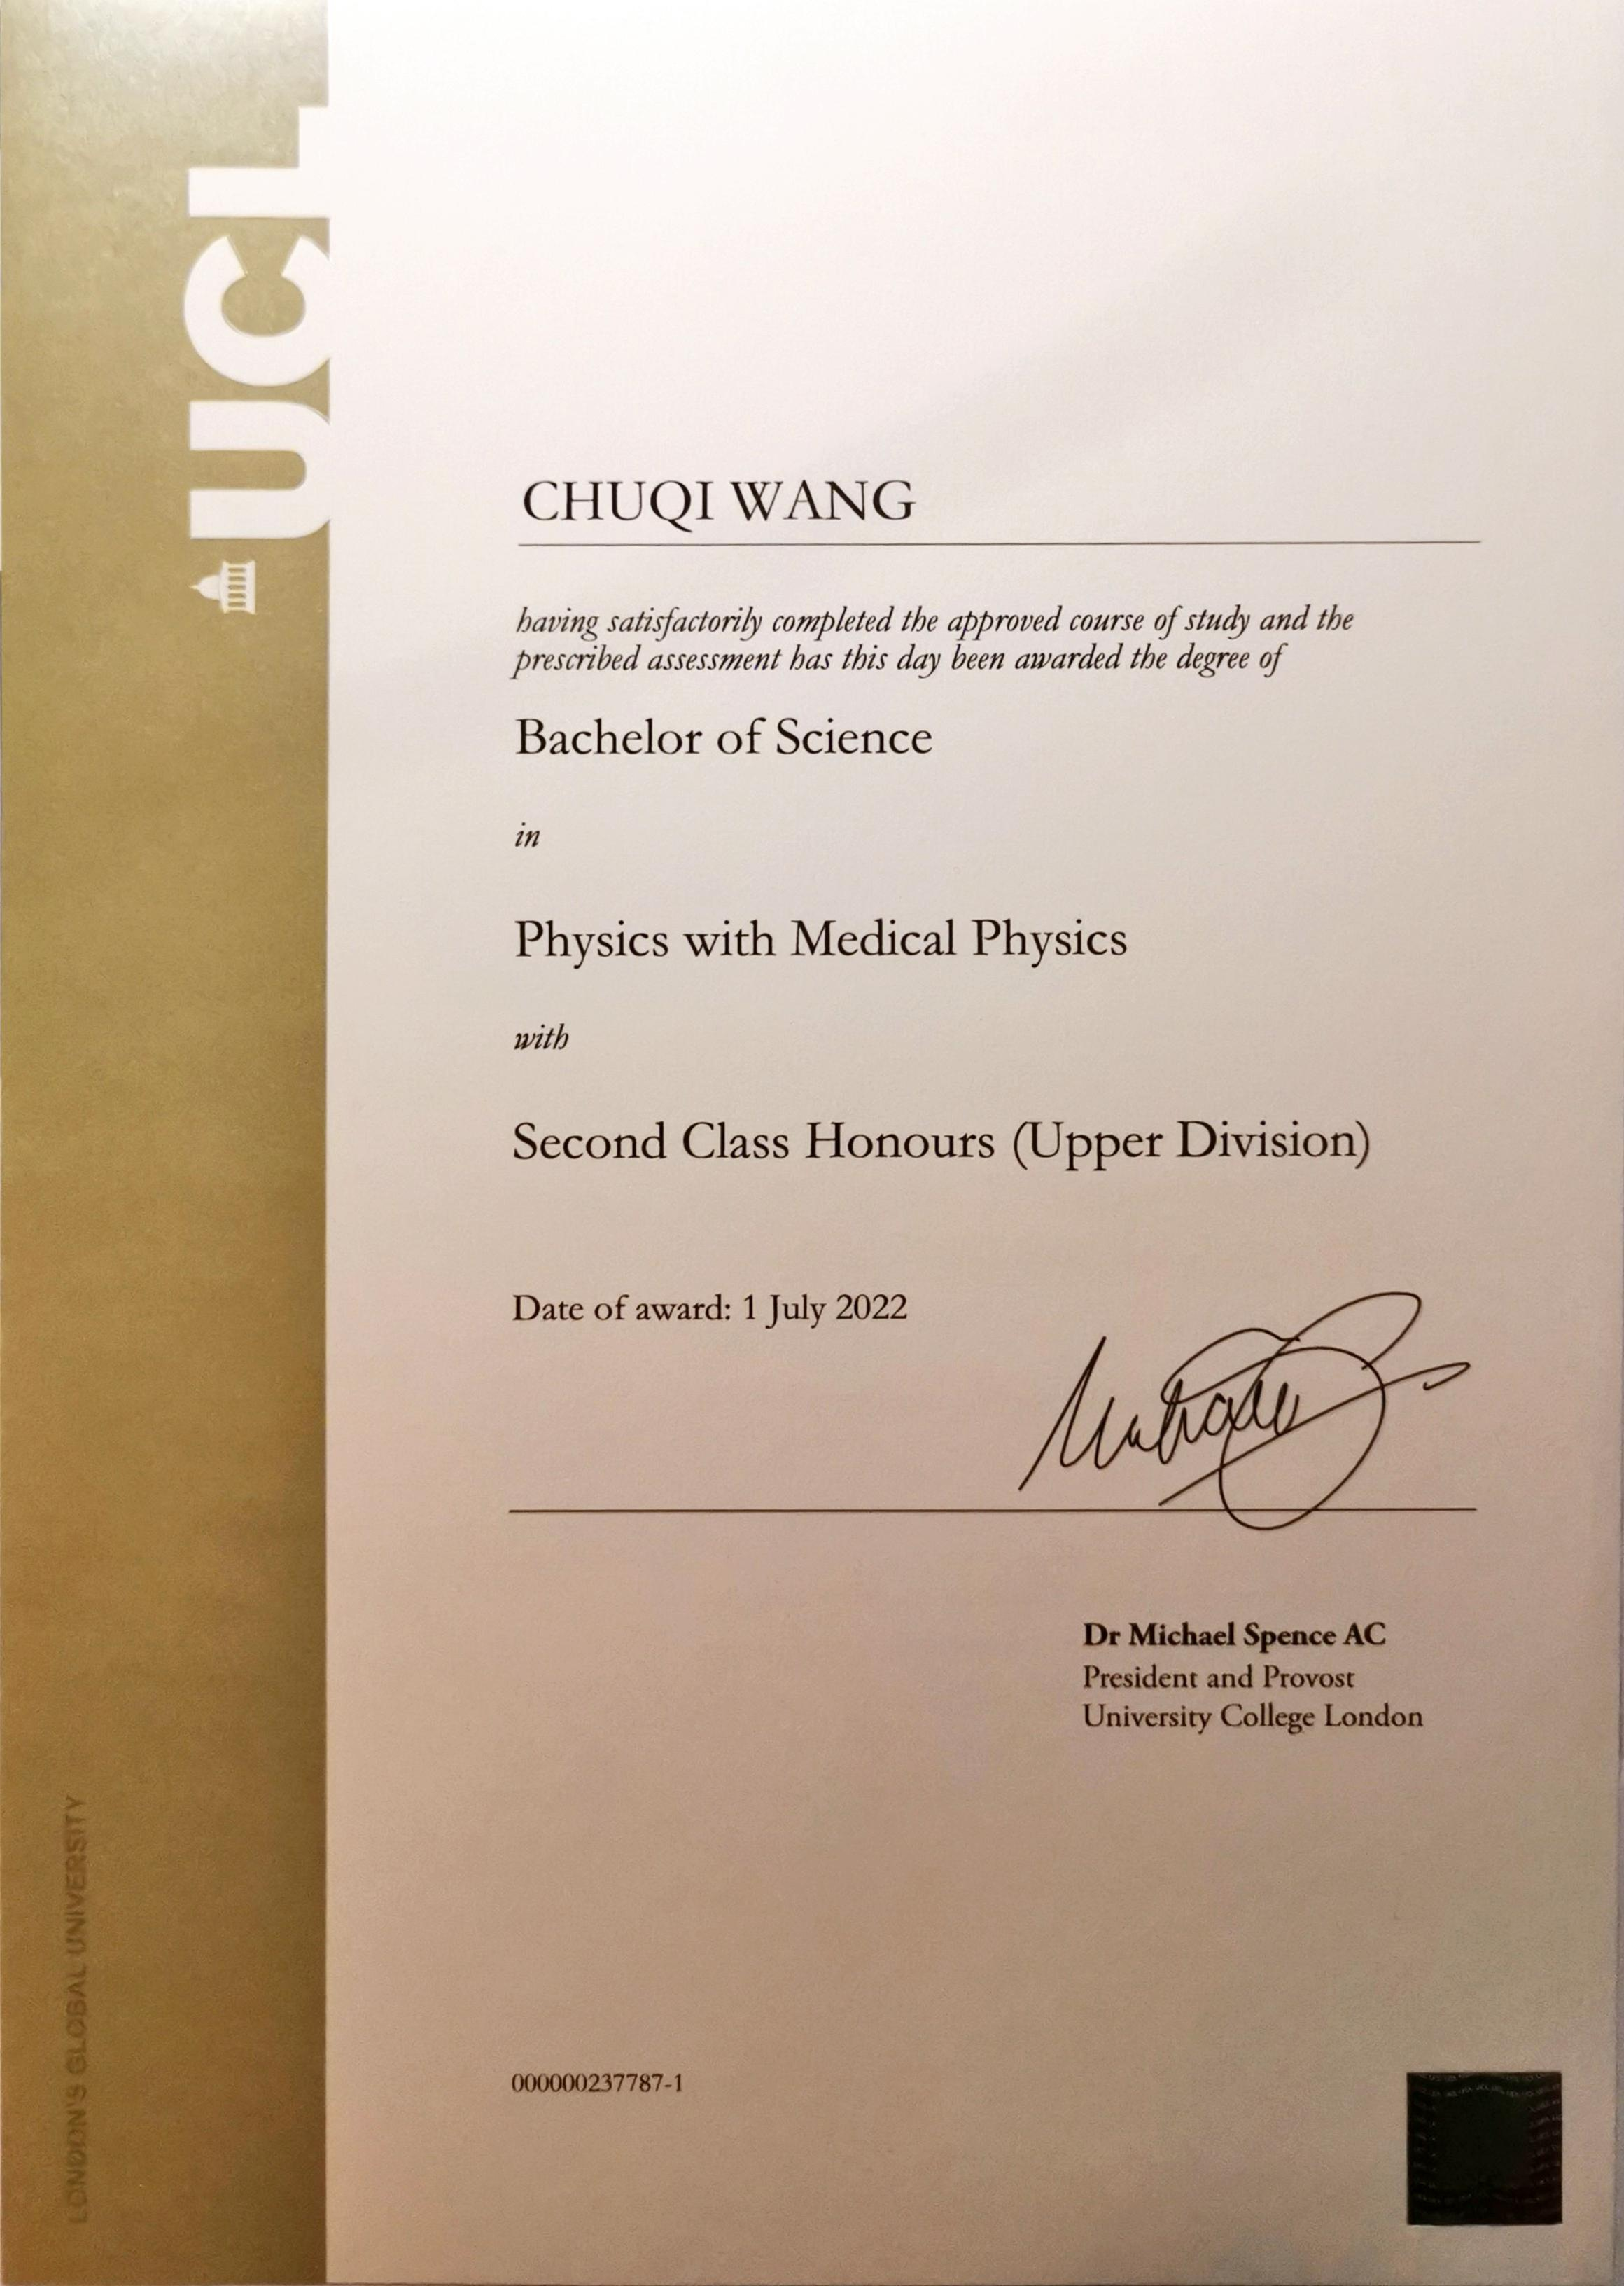

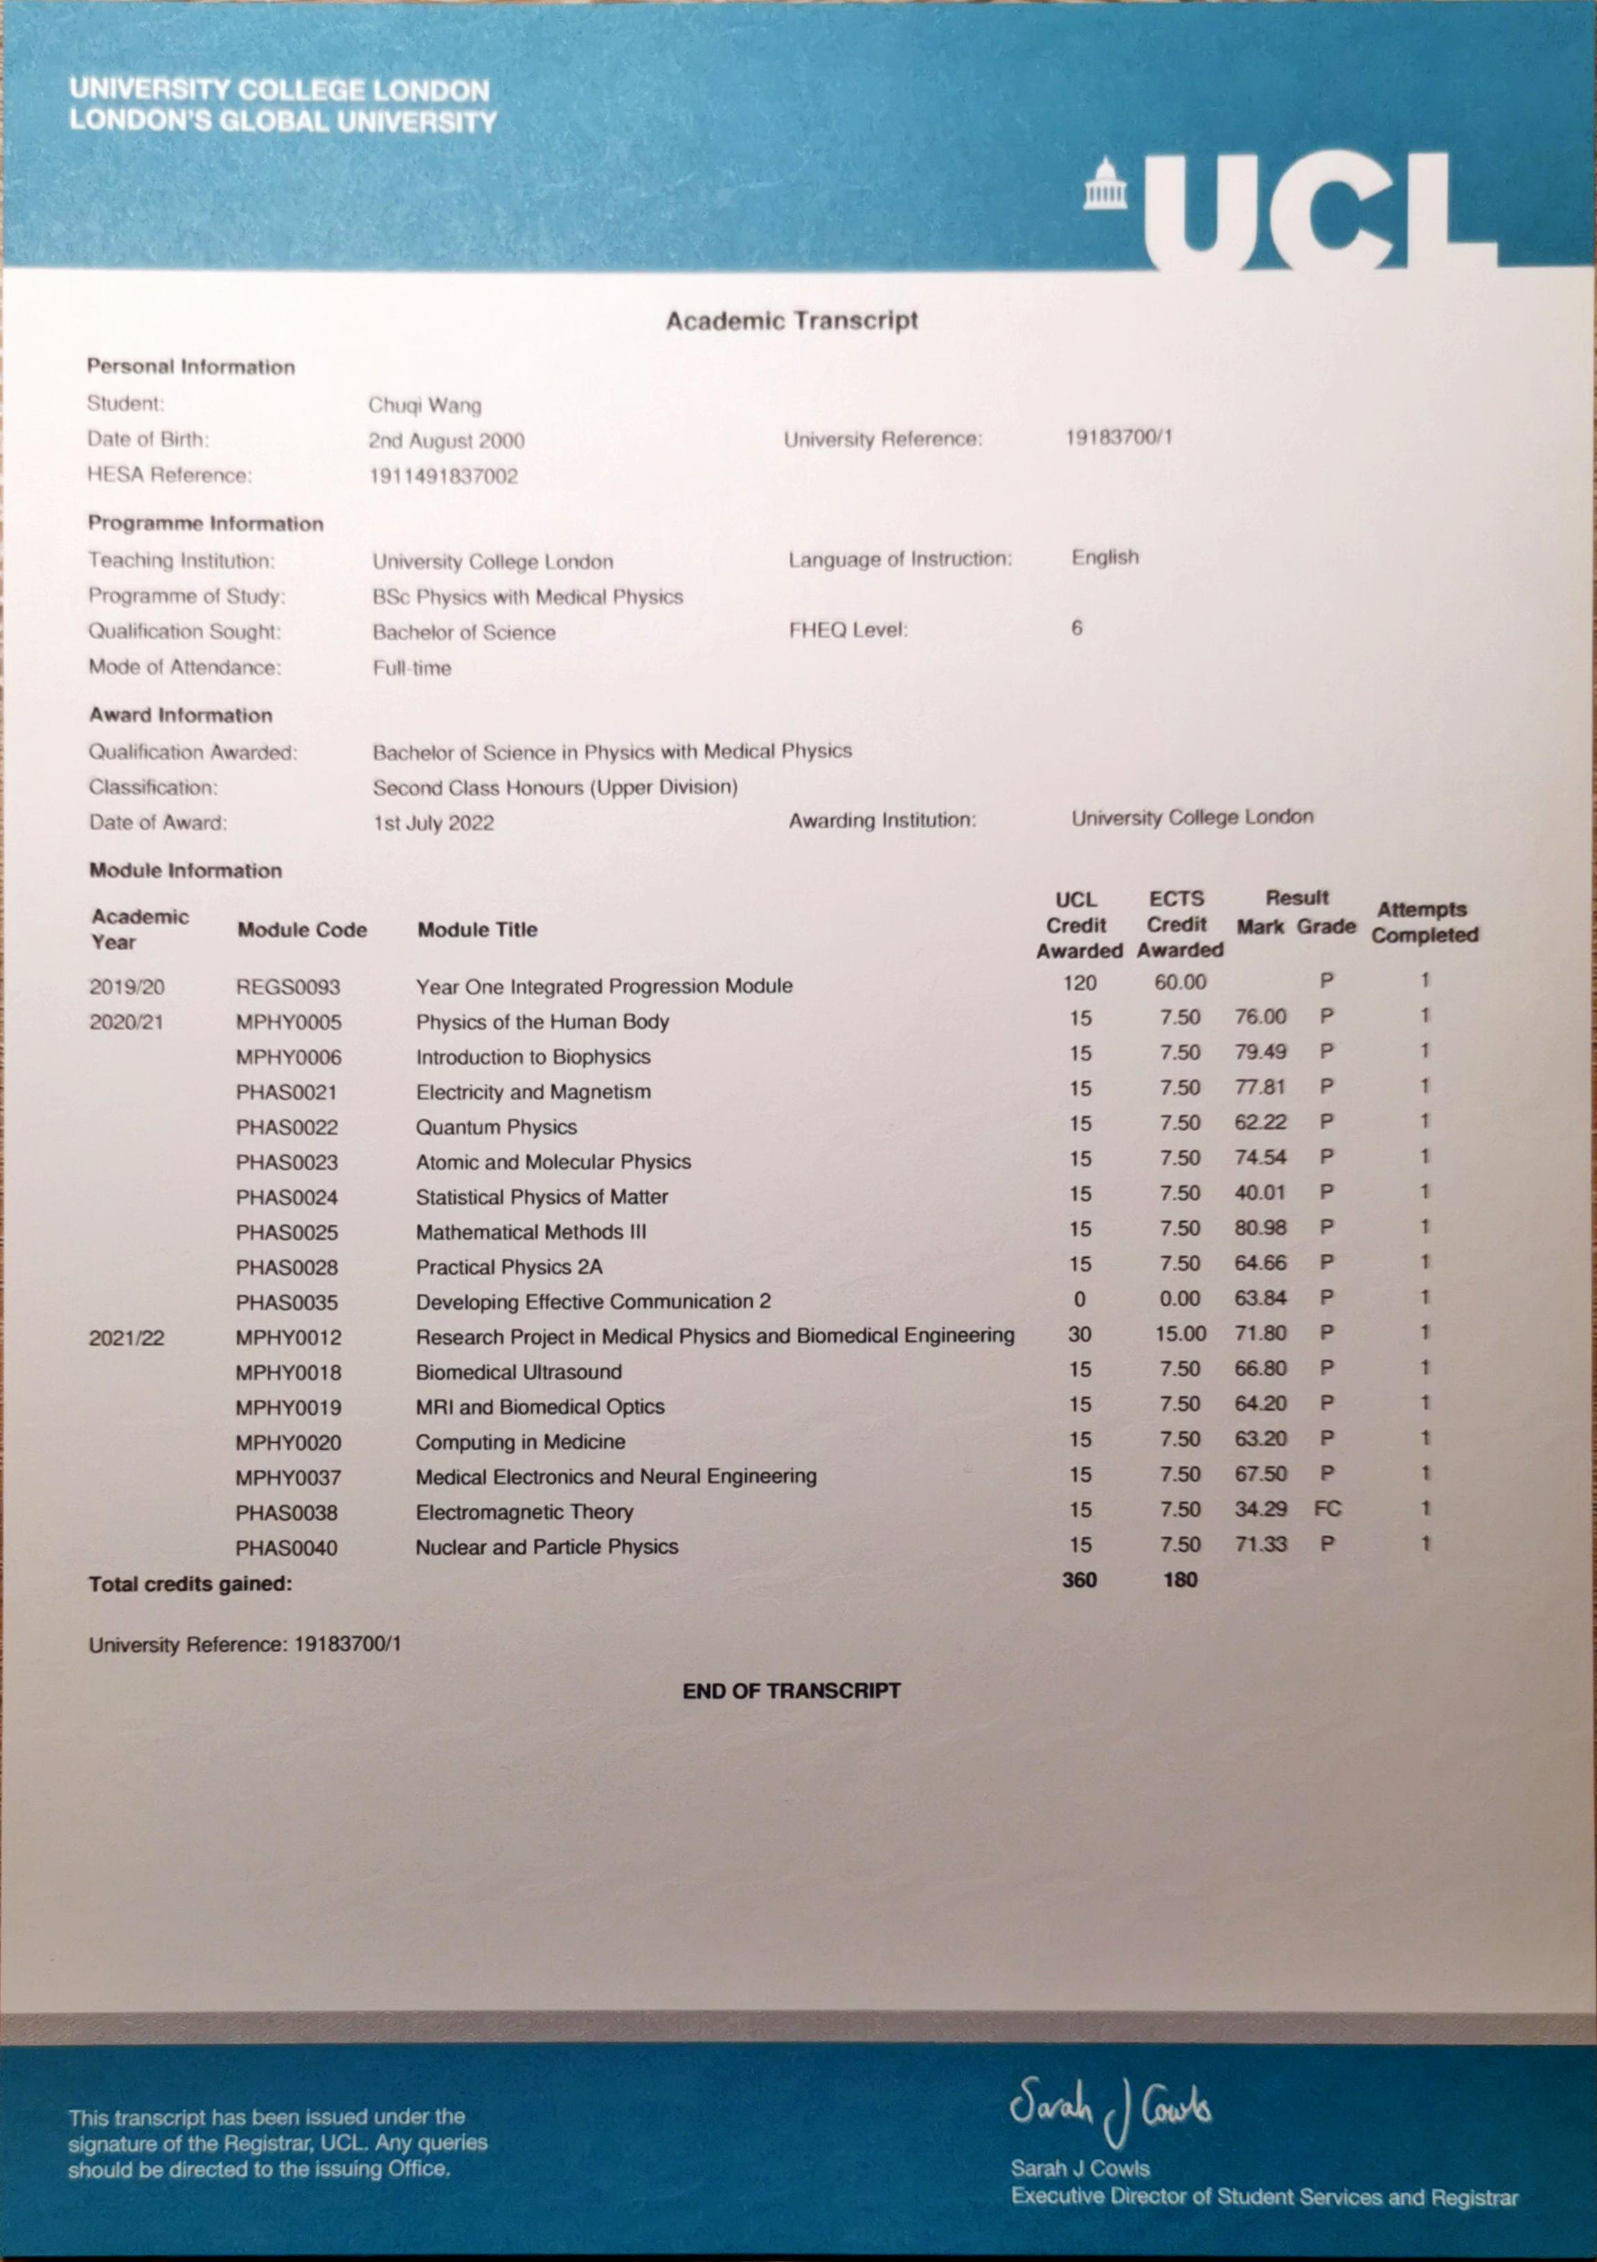

Financial statement
My parents are financially capable of fully covering both my tuition fees and living expenses throughout the duration of the MSc program. Additionally, I have personal savings, and I intend to undertake part-time jobs during holidays throughout the program to further support my financial needs.

